**Practical - 01**

**Aim: Implementing advanced deep learning algorithms such as convolutional neuralnetworks (CNNs) or recurrent neural networks (RNNs) using Python librarieslike TensorFlow or PyTorch.**

from keras.datasets import mnist

from keras.layers import Dense, Conv2D,Flatten

from keras.models import Sequential

import matplotlib.pyplot as plt

from google.colab import drive

drive.mount('/content/drive')

(train_images, train_labels), (test_images, test_labels)= mnist.load_data()

train_images.shape

test_images.shape

plt.imshow(train_images[1])

plt.imshow(test_images[1])

test_labels[1]

train_image,test_images=train_images/255.0,test_images/255.0

import numpy as np

train_images=train_images.reshape(60000,28,28,1)

test_images=test_images.reshape(10000,28,28,1)

from keras.utils import to_categorical

train_labels=to_categorical(train_labels)

test_labels=to_categorical(test_labels)

test_labels[1]

train_labels[1]

cnnmodel=Sequential()

cnnmodel.add(Conv2D(32,(3,3),activation='relu',input_shape=(28,28,1)))

cnnmodel.add(Conv2D(64,(3,3,),activation='relu'))

cnnmodel.add(Flatten())

cnnmodel.add(Dense(10,activation='softmax'))

cnnmodel.compile(optimizer='adam',loss='categorical_crossentropy',metrics=['accuracy'])

cnnmodel.fit(train_images,train_labels,epochs=3)

predictions=cnnmodel.predict(test_images)

predictions[1]

#import numpy as np

for i in range(3):

print(predictions[i])

print(test_labels[i])

**OUTPUT**

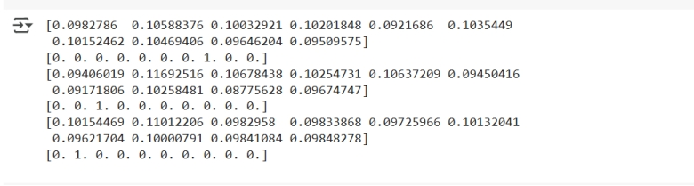

**Practical - 02**

**Aim: Building a natural language processing (NLP) model for sentiment analysis or text classification**

from sklearn.datasets import fetch_20newsgroups

from sklearn.feature_extraction.text import CountVectorizer

from sklearn.naive_bayes import BernoulliNB,MultinomialNB

from sklearn.model_selection import train_test_split

from sklearn.metrics import accuracy_score

newsgroup=fetch_20newsgroups(subset='all')

newsgroup.target_names

vectorizer1=CountVectorizer(binary=True)

vectorizer2=CountVectorizer(binary=False)

x1=vectorizer1.fit_transform(newsgroup.data)

x2=vectorizer2.fit_transform(newsgroup.data)

y=newsgroup.target

print(y)

xtrain1,xtest1,ytrain,ytest=train_test_split(x1,y,test_size=0.25,random_state=42)

xtrain2,xtest2,ytrain,ytest=train_test_split(x2,y,test_size=0.25,random_state=42)

bnb=BernoulliNB()

mnb=MultinomialNB()

bnb.fit(xtrain1,ytrain)

mnb.fit(xtrain2,ytrain)

y_pred1=bnb.predict(xtest1)

y_pred2=mnb.predict(xtest2)

accuracy_score(ytest,y_pred1)

accuracy_score(ytest,y_pred2)

OUTPUT

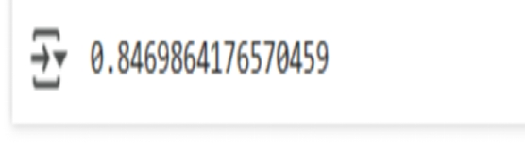

**Practical - 03**

**AIM: Developing a recommendation system using collaborative filtering or deep learning approaches**

import pandas as pd

ratings = pd.read_csv('BX-Book-Ratings.csv',encoding="latin-1",delimiter=";")

ratings

books=pd.read_csv('BX-Books (2).csv', encoding="latin-1")

books

ratings_books=pd.merge(ratings,books,on="ISBN")

ratings_books

ratings_books_sample=ratings_books.sample(frac=0.5,random_state=1)

ratings_books_sample

ratings_books_sample.to_csv('ravi.csv')

ratings_books_sample.columns

ratings_books_pivot=ratings_books_sample.pivot_table(index='Book-Title',columns='User-ID',values='Book-Rating').fillna(0)

ratings_books_pivot

from sklearn.neighbors import NearestNeighbors

model=NearestNeighbors(metric='cosine',algorithm='brute',n_neighbors=7, n_jobs=-1)

model.fit(ratings_books_pivot)

ratings_books_pivot.loc[["Cracking the Da Vinci Code : The Unauthorized Guide to the Facts Behind Dan Brown's Bestselling Novel"]]

#indices=model.kneighbors(ratings_books_pivot.loc[['Flesh Tones: A Novel']])

#indices

indices=model.kneighbors(ratings_books_pivot.loc[["Crossing Over"]])

indices

neighbor_indices = indices[1][0]

recommendations = ratings_books_pivot.index[neighbor_indices]

print(recommendations)

**OUTPUT**

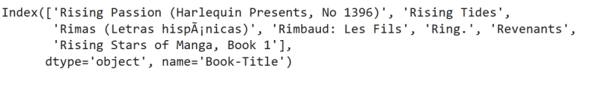

**Practical - 04**

**AIM: Applying reinforcement learning algorithms to solve complex decision-making problems**

Code:

import numpy as np

import random

# Define the environment

grid_size = 3 # Smaller grid

goal_state = (2, 2)

obstacle_state = (1, 1) # Single obstacle

actions = ['up', 'down', 'left', 'right']

action_to_delta = {

'up': (-1, 0),

'down': (1, 0),

'left': (0, -1),

'right': (0, 1)

}

# Initialize Q-table (simple 3D array for states and actions)

q_table = np.zeros((grid_size, grid_size, len(actions)))

# Parameters

alpha = 0.1 # Learning rate

gamma = 0.9 # Discount factor

epsilon = 1.0 # Exploration rate

epsilon_decay = 0.99

min_epsilon = 0.1

episodes = 200 # Fewer episodes

# Reward function

def get_reward(state):

if state == goal_state:

return 10 # Reward for reaching the goal

elif state == obstacle_state:

return -10 # Penalty for hitting the obstacle

return -1 # Step penalty

# Check if the new state is valid

def is_valid_state(state):

return 0 <= state[0] < grid_size and 0 <= state[1] < grid_size and state != obstacle_state

# Main Q-learning loop

for episode in range(episodes):

state = (0, 0) # Start at the top-left corner

total_reward = 0

while state != goal_state:

# Choose an action (epsilon-greedy

strategy) if random.uniform(0, 1) < epsilon:

action = random.choice(actions) # Explore

else:

action = actions[np.argmax(q_table[state[0], state[1]])] # Exploit best action

# Perform the action

delta = action_to_delta[action]

next_state = (state[0] + delta[0], state[1] + delta[1])

# Stay in the same state if the move is invalid

if not is_valid_state(next_state):

next_state = state

# Get reward and update Q-table

reward = get_reward(next_state)

total_reward += reward

best_next_action = np.max(q_table[next_state[0], next_state[1]])

q_table[state[0], state[1], actions.index(action)] += alpha * (

reward + gamma * best_next_action - q_table[state[0], state[1], actions.index(action)]

)

# Update state

state = next_state

# Decay epsilon

epsilon = max(min_epsilon, epsilon * epsilon_decay)

print(f"Episode {episode + 1}: Total Reward = {total_reward}")

# Display the learned policy

policy = np.full((grid_size, grid_size), ' ')

for i in range(grid_size):

for j in range(grid_size):

if (i, j) == goal_state:

policy[i, j] = 'G' # Goal

elif (i, j) == obstacle_state:

policy[i, j] = 'X' # Obstacle

else:

best_action = np.argmax(q_table[i, j])

policy[i, j] = actions[best_action][0].upper() # First letter of the best action

print("Learned Policy:")

print(policy)

**OUTPUT**

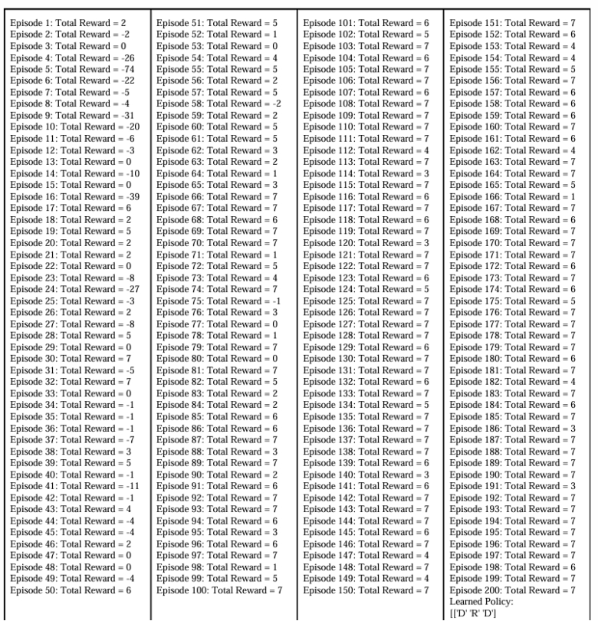

**Practical - 05**

**AIM: Building a deep learning model for time series forecasting or anomaly detection**

!pip install pycaret &>/dev/null

print("pycaret install sucessful")

from pycaret.utils import version

version()

from pycaret.datasets import get_data

from pycaret.classification import setup,compare_models,finalize_model,predict_model

data=get_data("diamond")

data.shape

data.info()

dataset=data.sample(frac=0.9,random_state=786)

dataset

data_unseen=data.drop(dataset.index)

dataset.shape,data_unseen.shape

dataset.reset_index(drop=True,inplace=True)

dataset

data_unseen.reset_index(drop=True,inplace=True)

data_unseen

from pycaret.regression import*

s=setup(data=dataset,target='Price',session_id=120)

best=compare_models()

final_model=create_model('xgboost')

print(final_model)

predict_model(final_model,data=data_unseen)

**OUTPUT**

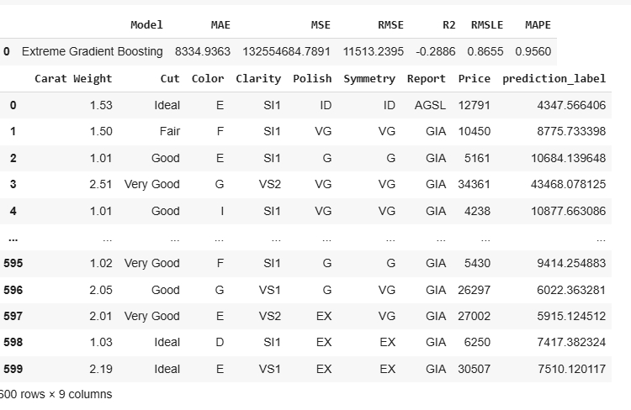

**Practical - 06**

**Aim: Implementing a machine learning pipeline for automated feature engineering and model selection.**

import numpy as np

import matplotlib.pyplot as plt

from tensorflow.keras.models import Model

from tensorflow.keras.layers import Input,Dense

normal_data = np.random.normal(0,1,(1000,2))

anomalous_data = np.random.uniform(5,10,(100,2))

normal_data[:3]

anomalous_data[:3]

len(normal_data),len(anomalous_data)

data=np.vstack([normal_data,anomalous_data])

labels=np.array([0] * len(normal_data) + [1] * len(anomalous_data))

data.shape

labels

labels.shape

def build_autoencoder(input_dim):

input_layer=Input(shape=(input_dim,))

encoded=Dense(4,activation='relu')(input_layer)

encoded=Dense(2,activation='relu')(encoded)

decoded=Dense(4,activation='relu')(encoded)

output_layer=Dense(input_dim,activation='linear')(decoded)

autoencoder=Model(inputs=input_layer,outputs=output_layer)

autoencoder.compile(optimizer='adam',loss='mse')

return autoencoder

autoencoder = build_autoencoder(input_dim=2)

autoencoder.fit(normal_data,normal_data,epochs=20)

reconstructed=autoencoder.predict(data)

reconstructed_error=np.mean((data-reconstructed)**2,axis=1)

reconstructed_error

predicted_labels=(reconstructed_error>40)

plt.scatter(data[:,0],data[:,1],

c=predicted_labels,cmap='coolwarm',alpha=0.6)

#plt.colorbar(label='Anomaly')

**OUTPUT**

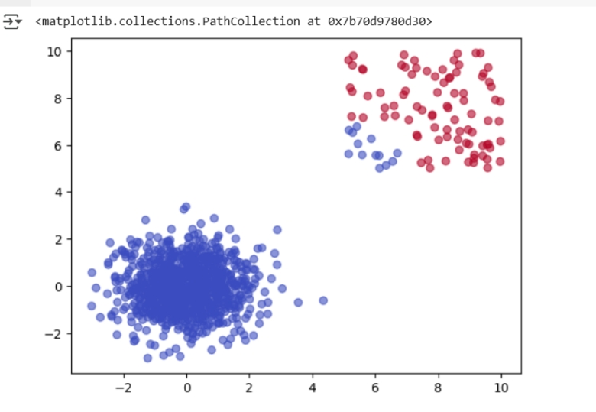

**Practical - 07**

**Aim: Using advanced optimization techniques like evolutionary algorithms or Bayesian optimization for hyperparameter tuning**.

! pip install pygad

import numpy as np

from sklearn.datasets import load_iris

from sklearn.model_selection import train_test_split

from sklearn.svm import SVC

from sklearn.metrics import accuracy_score

import pygad

data = load_iris()

X,y = data.data,data.target

xtrain,xtest,ytrain,ytest = train_test_split(X,y,test_size=0.2,random_state=42)

def fitness_func(ga_instance,solution,solution_idx):

C=solution[0]

gamma=solution[1]

kernel = ['linear', 'poly','rbf','sigmoid'][int(solution[2])]

if kernel not in ['linear','poly','rbf','sigmoid']:

return 0

model= SVC(C=C,gamma=gamma,kernel=kernel, random_state=42)

model.fit(xtrain,ytrain)

predictions=model.predict(xtest)

accuracy = accuracy_score(ytest,predictions)

return accuracy

ga_instance = pygad.GA(num_generations=50,num_parents_mating=5,fitness_func=fitness_func,sol_per_pop=10,num_genes=3,gene_space=[

{ 'low': 0.1, 'high': 10.0},

{ 'low': 0.0001, 'high': 1.0},

{ 'low': 0, 'high': 3, 'step': 1},

parent_selection_type="rank", keep_parents=2, crossover_type="single_point",

mutation_type="random",

mutation_percent_genes=10 )

ga_instance.run()

solution,solution_fitness,solution_idx = ga_instance.best_solution()

print (solution,solution_fitness,solution_idx)

C_best,gamma_best,kernel_best = solution

kernel_best = ['linear', 'poly','rbf','sigmoid'][int(kernel_best)]

kernel_best

best_model = SVC(C=C_best,gamma=gamma_best,kernel=kernel_best, random_state=42)

best_model.fit(xtrain,ytrain)

final_accuracy = accuracy_score(ytest,best_model.predict(xtest))

final_accuracy

**OUTPUT**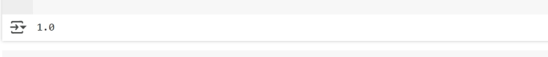

**Practical – 08**

**Aim- Experiment with neural networks like GANs (Generative Adversarial Networks) using Python libraries like TensorFlow or PyTorch to generate new images based on a dataset of images**

import torch

import torch.nn as nn

import torch.optim as optim

import torchvision

import torchvision.transforms as transforms

import matplotlib.pyplot as plt

from torch.utils.data import DataLoader

# Generator Model

class Generator(nn.Module):

def __init__(self, z_dim=100):

super().__init__()

self.model = nn.Sequential(

nn.Linear(z_dim, 256), nn.LeakyReLU(0.2),

nn.Linear(256, 512), nn.LeakyReLU(0.2),

nn.Linear(512, 1024), nn.LeakyReLU(0.2),

nn.Linear(1024, 28*28), nn.Tanh()

def forward(self, z):

return self.model(z).view(z.size(0), 1, 28, 28)

# Discriminator Model

class Discriminator(nn.Module):

def __init__(self):

super().__init__()

self.model = nn.Sequential(

nn.Flatten(),

nn.Linear(28*28, 1024), nn.LeakyReLU(0.2),

nn.Linear(1024, 512), nn.LeakyReLU(0.2),

nn.Linear(512, 256), nn.LeakyReLU(0.2),

nn.Linear(256, 1), nn.Sigmoid()

def forward(self, x):

return self.model(x)

# Data loading

transform = transforms.Compose([

transforms.ToTensor(), transforms.Normalize([0.5], [0.5])

])

train_loader = DataLoader(

torchvision.datasets.MNIST(root='./data', train=True, download=True, transform=transform),

batch_size=64, shuffle=True

)

# Model, optimizer and loss function

z_dim = 100

generator, discriminator = Generator(z_dim), Discriminator()

criterion = nn.BCELoss()

optimizer_gen = optim.Adam(generator.parameters(), lr=0.0002, betas=(0.5, 0.999))

optimizer_disc = optim.Adam(discriminator.parameters(), lr=0.0002, betas=(0.5, 0.999))

# Training loop

for epoch in range(20):

for real_images, _ in train_loader:

batch_size = real_images.size(0)

real_images = real_images.view(batch_size, -1)

# Labels

real_labels, fake_labels = torch.ones(batch_size, 1), torch.zeros(batch_size, 1)

# Train Discriminator

optimizer_disc.zero_grad()

d_loss_real = criterion(discriminator(real_images), real_labels)

d_loss_fake = criterion(discriminator(generator(torch.randn(batch_size, z_dim)).view(batch_size, -1)), fake_labels)

d_loss = d_loss_real + d_loss_fake

d_loss.backward()

optimizer_disc.step()

# Train Generator

optimizer_gen.zero_grad()

g_loss = criterion(discriminator(generator(torch.randn(batch_size, z_dim)).view(batch_size, -1)), real_labels)

g_loss.backward()

optimizer_gen.step()

# Print loss and save images

if (epoch+1) % 5 == 0:

print(f"Epoch [{epoch+1}/20], D Loss: {d_loss.item():.4f}, G Loss: {g_loss.item():.4f}")

with torch.no_grad():

fake_images = generator(torch.randn(64, z_dim)).view(64, 1, 28, 28)

fake_images = (fake_images + 1) / 2 # Rescale to [0, 1]

grid_img = torchvision.utils.make_grid(fake_images)

plt.imshow(grid_img.permute(1, 2, 0).cpu().numpy())

plt.show()

**Output**

